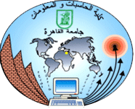

**The Final Project Task**

**Maximum Flow and Dijkstra Algorithm**

**Third Year- Computer Science**

**Spring Semester**

**Submitted to:**

**Dr. Mostafa Reda El-Tantawi**

**Team members:**

|  |  |  |
| --- | --- | --- |
| **Name** | **ID** | **Email** |
| Ahmed Sayed Mansour | 20170022 | ahmed.mans20719@gmail.com |
| Abdelrahman Bahig | 20170143 | abdelrahmanbahig04@gmail.com |
| Ibrahim Ramadan Abdou | 20170002 | ibrahemramadan130@gmail.com |
| Atef Magdy Metwally | 20170136 | atefmagdy12@gmail.com |
| Hatem Sayed Ali | 20170084 | hatemgad98@gmail.com |

* **Introduction :**

**Dijkstra's algorithm** is one algorithm for determining the shortest path from a starting node to a goal node in a weighted graph. The algorithm generates a tree of shortest paths to all other points of the graph from the beginning edge to the root.

A weighted graph can be added to the **Dijkstra's algorithm**, written in 1959 and named after its founder Dutch computer scientist Edsger Dijkstra. The line may be either guided or undirected. One stipulation to use the method is that any edge of the graph must have a non-negative weight.

**Maximum flow problems** include having a viable flow via a flow network which gets the maximum flow rate possible.

The problem of **maximal flow** can be used as a special case of more general issues of network traffic, including the problem of diffusion. The maximum s-t flow value (i.e. flow from source s to sink t) is equivalent to the minimum s-t cut capability (i.e. cutting s from t) in the network, as described in the min-cut theorem for max flow.

**The Ford-Fulkerson** process or algorithm Ford – Fulkerson (FFA) is a greedy algorithm that determines the optimal flow in a flow network. It is often named a "process" instead of a "algorithm" since it does not completely define the solution to seeking augmenting paths in a residual graph or it is defined in many implementations with different running times**. Ford & Fulkerson** In 1956, made the algorithm available. For the Edmonds – Karp algorithm, which is a specifically specified version of the Ford – Fulkerson system, the term "Ford – Fulkerson" is also used too.

The idea behind the algorithm is as follows: as long as there is a path from the source (start node) to the sink (end node), we send flow along one of the paths with the capacity available on all edges in the path. Instead we try that route, and so forth. An Augmenting Path is called a path with available capacity.

* **flow charts :**
  + 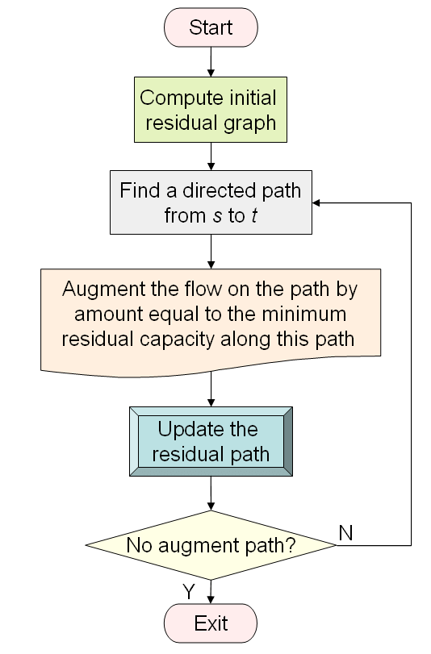**Maximum flow for ford-Fulkerson’s algorithm :**
  + **Dijkstra’s algorithm :**

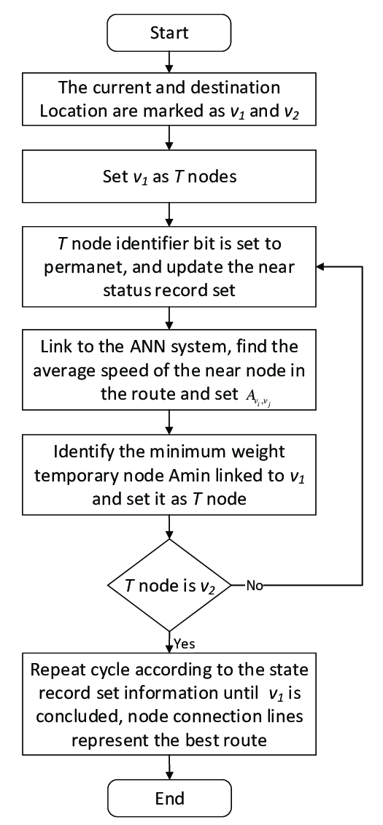

* 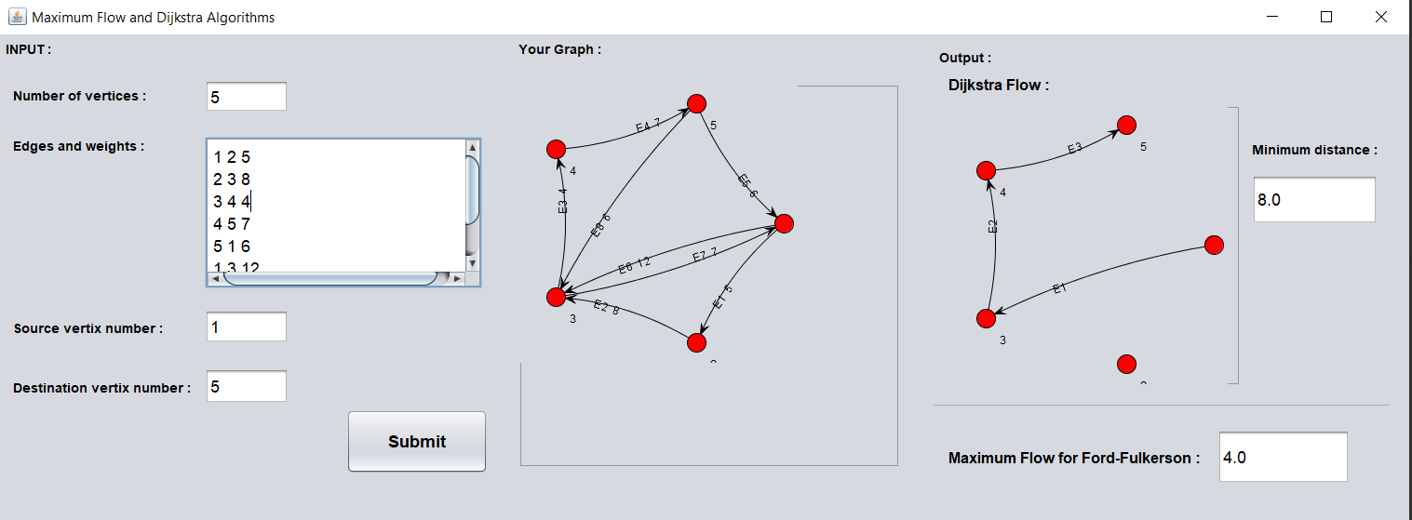**Snap Shots :**

3

9

8

7

1

10

Figure 1-GUI

6

5

4

2

|  |  |
| --- | --- |
| **Number** | **Description** |
| 1 | Input menu |
| 2 | Number of vertices |
| 3 | Edges : (Source – Destination – Weight) |
| 4 | Source Vertex |
| 5 | Destination Vertex |
| 6 | Submit button after finishing input data |
| 7 | Your input Graph |
| 8 | Dijkstra flow output |
| 9 | Minimum distance for Dijkstra algorithm |
| 10 | Maximum flow for Ford-Fulkerson Algorithm |

* **Output Discussion :**

In this photo (Figure 1-GUI), you will see an entire Snap Shot for the program where you can see an input area on the left to input the information of the graph.

At Number seven in (Figure 1-GUI), you can see the graph that you have entered.

On the right the Output area, which contains the Dijkstra flow showing the flow from the source to destination also the minimum distance calculated.

In addition, the Maximum flow calculated using Ford-Fulkerson algorithm.

* **Program Step-By-Step :**

1. 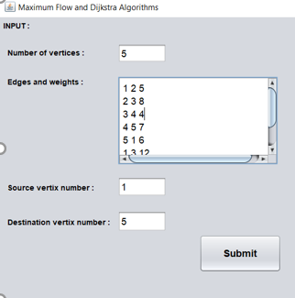**Input :**

In the input, we find that the vertices are taken as number.

In addition, the edges taken formatted (source - destination - weight).

Submit button clicked after inserting all data.

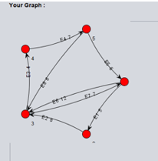

1. **Your graph :**

This layout shows your graph that you entered its data.

1. **Output :**
   1. 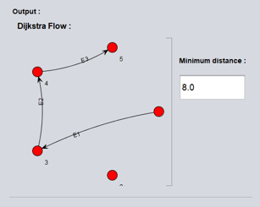 **Dijkstra’s Algorithm :**

For Dijkstra’s algorithm we shows its output flow that show the minimum distance can be calculated throw which nodes.

In addition, the minimum distance is calculated.

* 1. **Maximum flow for ford-Fulkerson’s algorithm :**

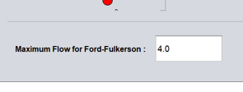For Maximum Flow for ford-Fulkerson’s algorithm we shows the value also in a box.

* **Pseudocodes :**
  + **Dijkstra's algorithm :**

1 **function** Dijkstra(*Graph*, *source*):

2

3 create vertex set Q

4

5 **for each** vertex *v* in *Graph*:

6 dist[*v*] ← INFINITY

7 prev[*v*] ← UNDEFINED

8 add *v* to *Q*

10 dist[*source*] ← 0

11

12 **while** *Q* is not empty:

13 *u* ← vertex in *Q* with min dist[u]

14

15 remove *u* from *Q*

16

17 **for each** neighbor *v* of *u*: *// only v that are still in Q*

18 *alt* ← dist[*u*] + length(*u*, *v*)

19 **if** *alt* < dist[*v*]:

20 dist[*v*] ← *alt*

21 prev[*v*] ← *u*

22

23 return dist[], prev[]

* + **Maximum flow for ford-Fulkerson’s algorithm :**
* function: FordFulkerson(Graph G,Node S,Node T):
* Initialise flow in all edges to 0
* while (there exists an augmenting path(P) between S and T in residual network graph):
* Augment flow between S to T along the path P
* Update residual network graph
* return
* **Implementation :**
* **Conclusion :**
* **Suggestions for related future work :**

I suggest for a related future work with Dijkstra Algorithm and Maximum Flow algorithms is to apply those algorithms on a real problems in real life like:

* + - * + Geographical Maps.
        + Find locations of Map, which refers to vertices of graph.
        + IP routing to find Open shortest Path First.
        + The telephone network.
        + Airline Scheduling.

Appling our algorithms will also help us to understand those algorithms efficiently.

In addition working on such a big Project with better algorithms will increase the efficiency and performance of our applications.

* **References :**
  + - 1. Controversial, see Moshe Sniedovich (2006). "Dijkstra's algorithm revisited: the dynamic programming connexion".
      2. Frana, Phil (August 2010). "An Interview with Edsger W. Dijkstra". Communications of the ACM.
      3. Hall, A. How to use Dijkstra's algorithm. Retrieved April 27, 2016, from <https://www.youtube.com/watch?v=Cjzzx3MvOcU>
      4. Schrijver, A. (2002). "On the history of the transportation and maximum flow problems".
      5. Felner, Ariel (2011). Position Paper: Dijkstra's Algorithm versus Uniform Cost Search or a Case against Dijkstra's Algorithm. Proc. 4th Int'l Symp.
      6. Cormen, Thomas H.; Leiserson, Charles E.; Rivest, Ronald L.; Stein, Clifford (2001). "Section 26.2: The Ford–Fulkerson method". Introduction to Algorithms (Second Ed.). MIT Press and McGraw–Hill.
      7. George T. Heineman; Gary Pollice; Stanley Selkow (2008). "Chapter 8: Network Flow Algorithms". Algorithms in a Nutshell. Oreilly Media.
      8. Backman, Spencer; Huynh, Tony (2018). "Transfinite Ford–Fulkerson on a finite network".